Ⅲ. System Design and Implementation

1.Overview

We already know that some companies try to have discount health insurance plans with some limited methods. And there is no way to attract more clients by these ways because many of them are time-consuming and inaccurate. So we decide to put lightweight low-power camera for client to capture information. And this method is convenient and scientific which would not invade the privacy of clients and would not disturb their daily life because the camera is so small. And after this step, what we need to do is to get enough and accurate information from the pictures the camera shoots. And the camera can reuse for many times to reduce cost.

Our functions of system are cater to the requirements from clients. First, we can not get any other information other than images. So our task is to analyze these pictures carefully to get exactly what we need. We team decide to choose images from their food, drinks, drugs and exercise. We use all of these aspects to evaluate their health habits with score, and then we can set a score line to filter the clients we want.

The fact is that if we have one client to evaluate, we could analyze almost 100-200 photos in one month period. But UPMC has millions of insurance clients to evaluate which traditional process method can not deal with. That is because the pictures of millions of people would take huge hardware memory device to store. Besides to storage problem, we also need high-speed processing unit to analyze all the photos quickly.  Based on these conditions,  it is impossible for UPMC to investment lots of money on hardware and CPU to figure out one insurance problem. As a result, our team is going to design our system based on cloud computing service, which we can not only store all the image in it but also call functions to process pictures by cloud computing processing unit. What we only have to pay is the service fee, which is much cheaper than buying all of the storage and processing facilities.

2. Design Structure

And we found there are many cloud computing service providers. What we should do firstly is to design the whole structure by our demands. Then we can decide which service provider is the best choice to accomplish our requirements.

Firstly, for each person we have hundreds of pictures about diet and exercise and so on. We should figure out that our team do not have too many storage to save all the data.  In order to make everything clear, we apply Amazon Web Service as basis to show our system architecture. As the chart shown below, user S3 bucket should firstly transfer all the data to upload S3 bucket. After this step, the AWS LAMBDA will take pictures from this bucket by permission of credential. And we have already coded some programs in LAMBDA. LAMBDA can process all of the pictures follow our instructions.

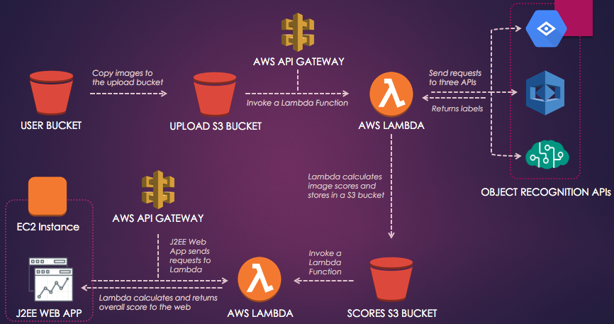

It would call 3 different APIs to detect all the labels in pictures. Why we choose 3 APIs to be involved is that we think it can reduce risk of failure of recognition when picture is in extreme situation. For example, the rest APIs can work normally when one of the vision recognition API can not figure what the picture contains. Now, we can use multiple threads to request labels for corresponding pictures. To avoid possible misleading information because of difference of response time, we are going to give every image an index. This index is not only used in uploading procedure but also used in giving tags to returned results from APIs. And when we want to show labels of each picture, we could track the result by index value. All the returned labels and index would be stored in another S3 bucket---SCORES S3 Bucket. Another LAMBDA can upload the data in scores bucket to calculate the total score and we focus on the score. Each picture should has a score to display its effect on the final insurance discount decision. In order to consider every tiny labels into the score, we create a dictionary to store vocabularies related to health conditions. For each element in the dictionary, we set a pair value to indicate the attribute of one label. If one label is benefit to one’s health, it will be a positive value, vise versa. Beside to this, we also give weight value to different API because some API performs better than other API. So we calculate each point of the label and multiply with the weight value. And then we add all the label points to get the total score of one picture. And we can add all of the scores of pictures to get a final one.

As shown in the chart, UPMC insurance manager can log in the web app by credentials and request health information for certain client. The manager input the id of client and then web can returned one scatter diagram. Each scatter point represent one picture with index and score. And the total score for the client would also shown in the webpage. So the manager can judge whether give this client the discount right.

And we can see, there is no need for UPMC to purchase hardware and software, All UPMC need to do is to hire people like us to develop the whole system and pay for the cloud server service fee. By this way, UPMC can reduce a lot of cost. And there are more advantages:

1. The whole evaluation process is transparent to both client and UPMC manager. What they just to do is keep their routine life and wait for the result without doing anything.

2. By using cloud service, it is more accurate and safe. Because now nobody can lie in the health habits, every results are calculated by advanced recognition API and algorithm scientifically. And nobody can access these data without credentials, which improved the privacy safety.